TASK 1
#include<stdio.h>
int main()
{ int Batch_Year = 26;
char Section = 'A';
float Test_Score = 65.00;
double Semester_Fees = 180000;

printf("==============================================\n");
printf(" FAST-NUCES STUDENT PROFILE CARD\n");
printf("==============================================\n");
printf(" Batch Year : %d \n",Batch_Year);
printf(" Section : %c \n",Section);
printf(" Test Score : %.2f \n",Test_Score);
printf(" Semester Fees : %.2f \n",Semester_Fees);
printf(" Motto : Small daily step leads to big success\n");

printf("==============================================\n");
return 0;
}
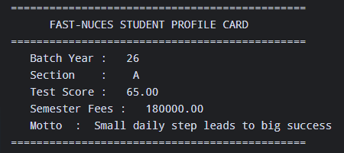

TASK 2
#include<stdio.h>
int main()
{
printf("========== C ESCAPE SEQUENCES REFRENCE ==========\n");
printf("1. To print a double quote, write: \\\"\n");
printf("2. To print a literal backslash, write: \\\\\n");
printf("3. To insert a newline break, write: \\n\n");
printf("4. To insert a horizental tab stop, write: \\t\n");
printf("5. To print a percent sign, write: %%%\n");
printf("=================================================\n");

return 0;
}

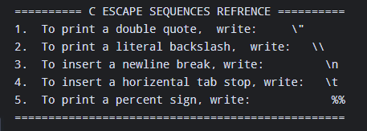

TASK 3
#include<stdio.h>
int main()
{
int x = 10;
char y = 'M';
float z = 3.1415;
double a = 87.846486;

printf(" Type name Variable value Size in memory\n");
printf("-------------------------------------------------------\n");
printf("char %c 1 byte\n",y);
printf("int %d 4 bytes\n",x);
printf("float %.2f 4 bytes\n",z);
printf("double %.2f 8 bytes\n",a);
printf("-------------------------------------------------------\n");

return 0;

}

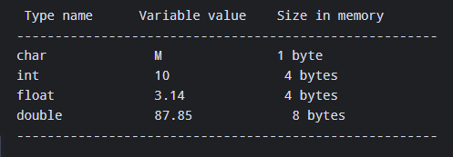
TASK 4
#include<stdio.h>
int main()
{
float Celcious = 20.40;
float Fahrenheit = Celcious * 9.0/5.0 + 32.0;
float Kelvin = Celcious + 273.15;

printf("========== TEMPRETURE CONVERSION =========\n");
printf(" Temperature in Celcius : %.2f\n",Celcious);
printf(" Temperature in Fahrenheit : %.2f\n",Fahrenheit);
printf(" Temperature in Kelvin : %.2f\n",Kelvin);
printf("===========================================\n");

return 0;

}

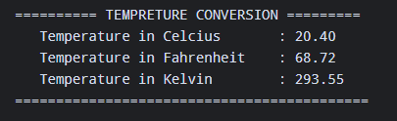

TASK 5
#include<stdio.h>
int main()
{
float radius = 7.5;
float pi = 3.1415;
float dimeter = 2 * radius;
float circumference = 2 * pi * radius;
float area = pi * radius * radius;

printf("========== CIRCLE GEOMETRY REPORT ==========\n");
printf(" Given radius : %.2f cm \n",radius);
printf(" Calculated dimeter : %.2f cm\n",dimeter);
printf(" Calculated circumference : %.2f cm\n",circumference);
printf(" Calculated area : %.2f sq cm \n",area);
printf("=============================================");

return 0;

}

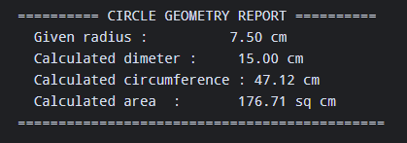

TASK 6
#include<stdio.h>
int main()
{
float Vi = 12.5;
float A = 3.2;
float T = 6.0;

float Vf = Vi + (A * T);
float S = (Vi * T)+(0.5 * A * T * T);

printf("========== KINEMATICS MOTION REPORT ==========\n");
printf(" Initial Velocity (Vi) : %.2f m/s\n",Vi);
printf(" Acceleration (A) : %.2f m/s^2 \n",A);
printf(" Time Elapsed (T) : %.2f s \n",T);
printf("----------------------------------------------\n");
printf(" Calculated Final Velocity (Vf) : %.2f m/s \n",Vf);
printf(" Calculated Distance (S) : %.2f m \n",S);

printf("==============================================");
return 0;
}
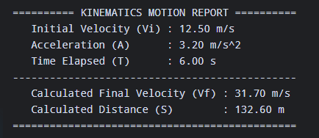
TASK 7
#include<stdio.h>
int main()
{ double principal = 120000.00;
float rate = 8.5;
int time = 3;
float interest =(principal * rate * time)/100.0;
float payable_amount = principal * interest;
float monthly_installment = payable_amount/(time * 12.0);
printf("========== BANK LOAN INTEREST SUMMARY==========\n");
printf(" principal amount : PKR %.2f \n",principal);
printf(" annual interest rate : %f %% \n",rate);
printf(" loan duration : %d years \n",time);
printf("-----------------------------------------------\n");
printf(" total accured interest : PKR %.2f \n",interest);
printf(" total payable amount : PKR %.2f \n",payable_amount);
printf(" monthly installments : PKR %.2f \n",monthly_installment);
printf("==================================================");
return 0;
}

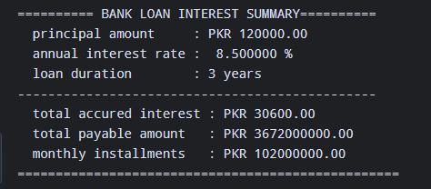
TASK 8
#include<stdio.h>
int main()
{
double basic_salery = 60000.00;
float hra = .20 * basic_salery;
float ma = .10 * basic_salery;
float gs = basic_salery + hra + ma;
float itd = .05 * gs;
float ns = gs - itd;
printf("========== MONTHLY SALERY SLIP ==========\n");
printf(" basic salery : \t PKR %.2f \n",basic_salery);
printf(" house rent allowance : PKR %.2f \n",hra);
printf(" medical allowance \t: PKR %.2f \n",ma);
printf("-----------------------------------------\n");
printf(" gross salery \t: PKR %.2f\n",gs);
printf(" tax deduction (5%) : PKR %.2f \n",itd);
printf("-----------------------------------------\n");
printf(" net payable salery : PKR %.2f \n",ns);
printf("=========================================\n");

return 0;
}

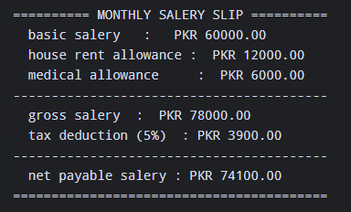

TASK 9
#include<stdio.h>
int main()
{
float pf_marks = 88.0;
int pf_hours = 3;
float calculus_marks = 76.5;
int c_hours = 3;
float physics = 82.0;
int p_hours = 2;

double total_score = (88.0 * 3)+(76.5 * 3)+(82.0 *2);
int total_hours = 8;
double average_percentage = total_score/total_hours;

printf("========== SEMESTER ACADAMIC REPORT ==========\n");
printf(" Course\t Credit hours\t Obtained marks\n");

printf("----------------------------------------------\n");

printf(" programming found.\t %d\t %.2f\n",pf_hours,pf_marks);
printf(" calculus \t %d\t %.2f\n",c_hours,calculus_marks);
printf(" physics \t %d\t %.2f\n",p_hours,physics);

printf("----------------------------------------------\n");

printf(" total credit hours : %d\n",total_hours);
printf(" a percentage \t : %.2f\n",average_percentage);

printf("==============================================\n");

return 0;
}
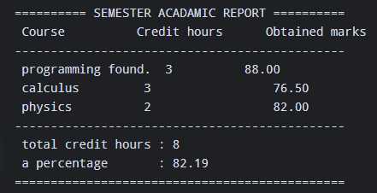

TASK 10
#include<stdio.h>
int main()
{
int tea = 3;
float t_price = 60.00;
int samosa = 4;
float s_price = 40.50;
int roll = 2;
float r_price = 120.00;

double t_total = tea * t_price;
double s_total = samosa * s_price;
double r_total = roll * r_price;

double subtotal = t_total + s_total + r_total;
double gst = .16 * subtotal;
double fpa = subtotal * gst;

printf("========== FAST CAFETERIA RECIPT ==========\n");
printf(" item qty unit RS subtotal\n");
printf("-------------------------------------------\n");
printf(" tea %d %.2f %.2f\n",tea,t_price,t_total);
printf(" samosa %d %.2f %.2f\n",samosa,s_price,s_total);
printf(" chicken roll %d %.2f %.2f\n",roll,r_price,r_total);
printf("-------------------------------------------\n");
printf(" subtotal : PKR %.2f\n",subtotal);
printf(" GST (16%) : PKR %.2f\n",gst);
printf("--------------------------------------------\n");
printf(" grand total : PKR %.2f\n",fpa);

printf(" ======= THANK YOU FOR YOUR VISIT =======\n");

return 0;

}

